**Spring Rest Handson  
  
Create a spring web project using Maven  
  
SpringlearnApplication.java**package com.cognizant.springlearn;

import org.springframework.boot.SpringApplication;

import org.springframework.boot.autoconfigure.SpringBootApplication;

@SpringBootApplication

public class SpringlearnApplication {

public static void main(String[] args) {

SpringApplication.run(SpringlearnApplication.class, args);

System.out.println("\n\nThis is a simple Spring Application");

}

}  
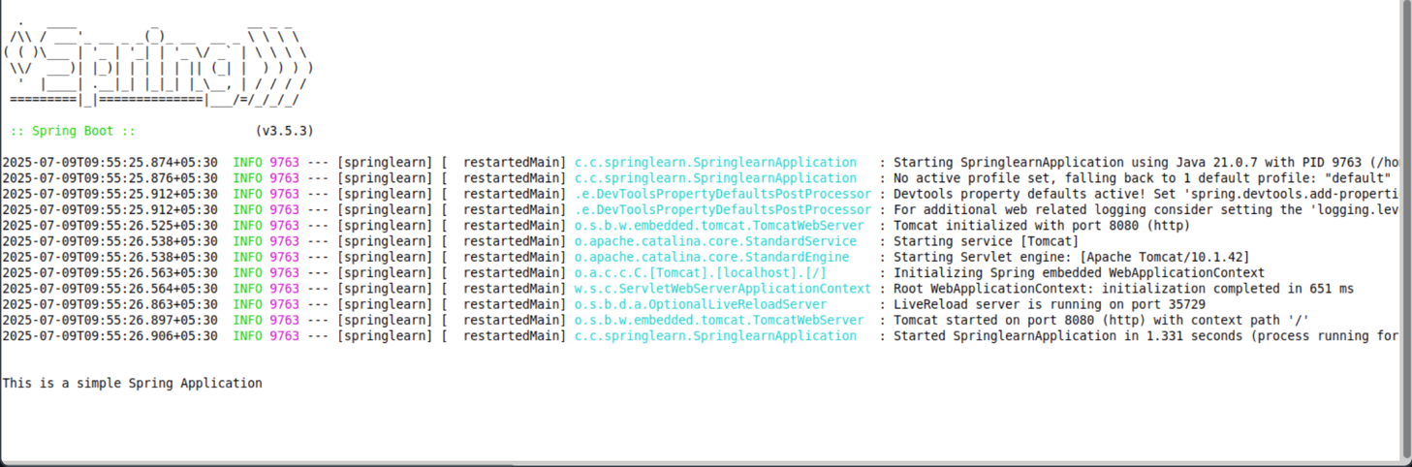  
  
  
  
**Spring Core – Load Country from Spring Configuration XML**  
  
package com.cognizant.springlearn;

import org.springframework.boot.SpringApplication;

import org.springframework.boot.autoconfigure.SpringBootApplication;

import org.springframework.context.ApplicationContext;

import org.springframework.context.support.ClassPathXmlApplicationContext;

import java.text.SimpleDateFormat;

import java.util.Date;

@SpringBootApplication

public class SpringLearnApplication {

public static void main(String[] args) {

SpringApplication.run(SpringLearnApplication.class, args);

displayDate();

}

public static void displayDate() {

ApplicationContext context = new ClassPathXmlApplicationContext("date-format.xml");

SimpleDateFormat format = context.getBean("dateFormat", SimpleDateFormat.class);

try{

Date date = format.parse("31/12/2018");

System.out.println();

System.out.println(date);

}catch (Exception e) {

System.out.println(e.getMessage());

}

}

}  
